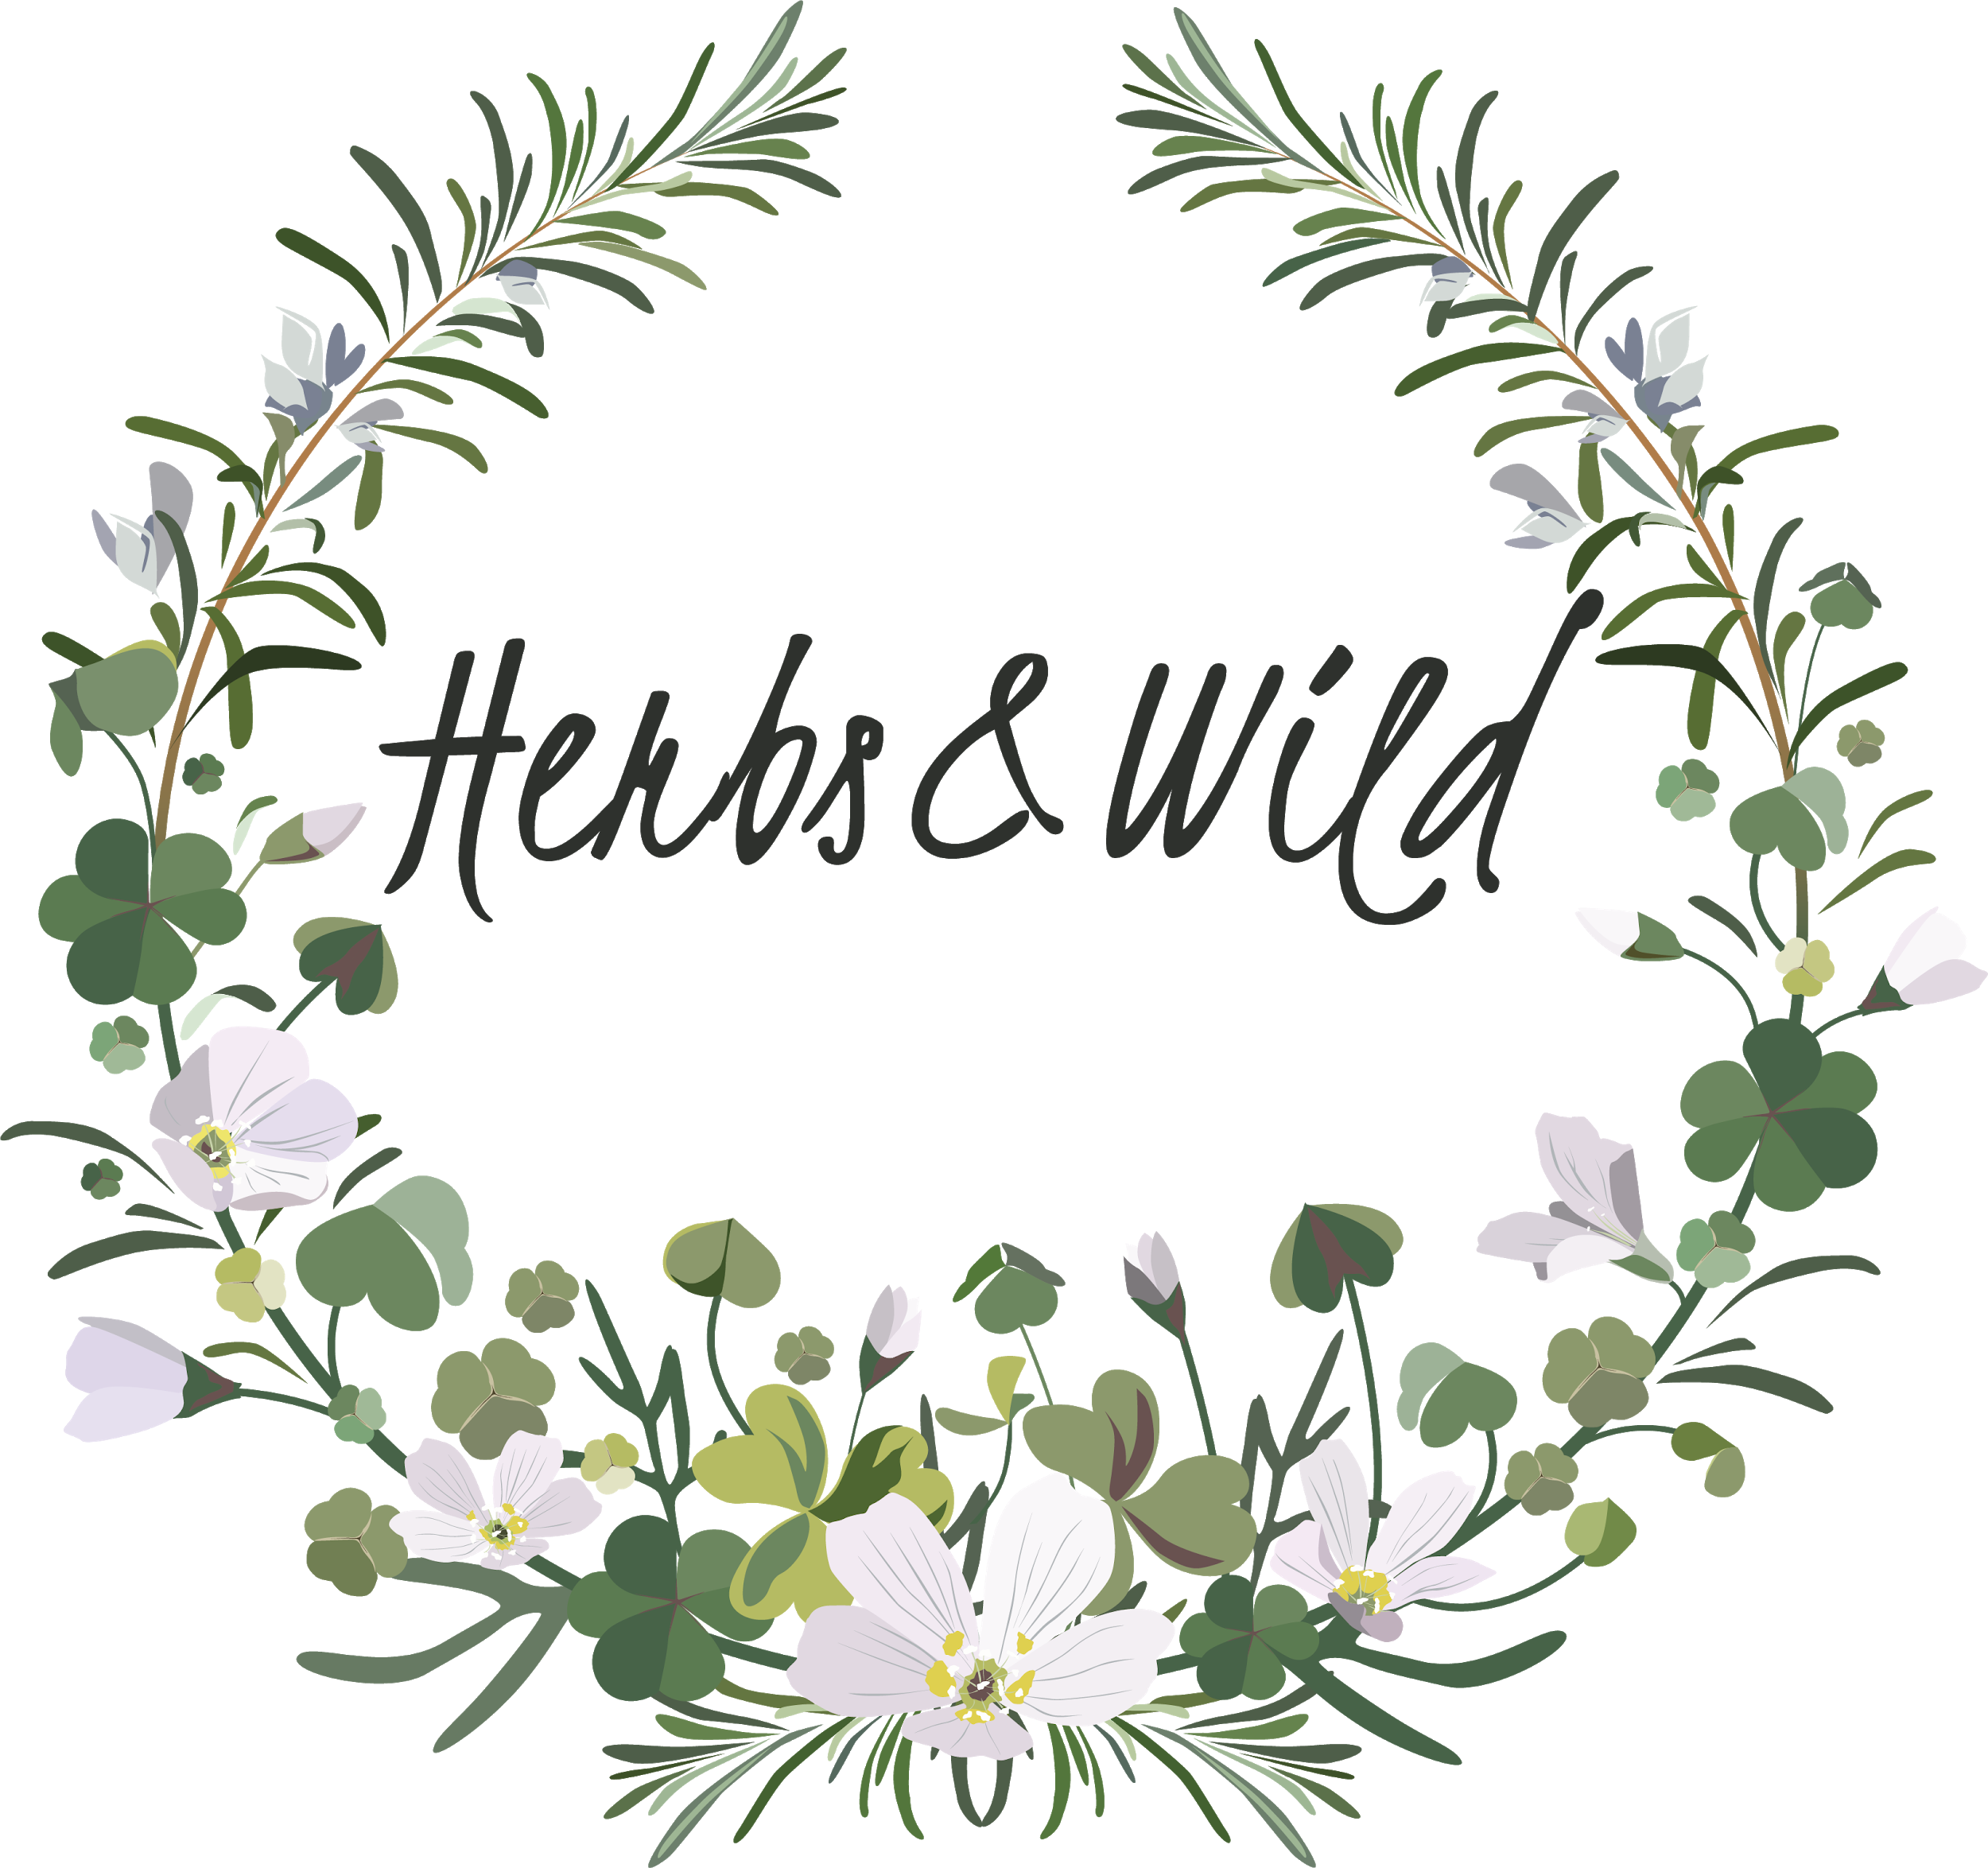
End-of-Winter Menu

~ Welcome Cocktail~
PARSLEY, CHERVIL, PURSLANE
Cured mackerel, crispy skin, gooseberry
salsa, sprouted rye sourdough

WILD GARLIC, ROSEMARY
Rolled Gambledown leg of lamb, fava bean
glaze, creamy potatoes, hispi cabbage

MAGNOLIA BLOSSOM, MEADOWSWEET
Pear and cobnut frangipane tart, ginger
ice-cream, meadowsweet vinegar gel

~Herbal Tea & Confectionary~

